University of Puerto Rico, Mayagüez Campus
Industrial Engineering Department
ININ 4027: Design and Analysis of Engineering Experiments
Dra. Wandaliz Torres García

Final Project Report: Simulation of Experiment – Cart Acceleration

Group #2
Camila V. Rodríguez Morales
Paola M. Oliver Morales
Gabriela M. Hernández Delgado
Introduction
  - Background Information
A group of engineers at a manufacturing company are interested in implementing a gravity-driven transport system to move products between two stations. The system consists of a cart traveling down a ramp, relying solely on gravity rather than powered equipment. To ensure a safe system, the engineers must guarantee that the cart moves at an ideal acceleration; excessive acceleration may damage the product, while insufficient acceleration may affect the production flow and reduce overall efficiency. To begin their study, the team conducted preliminary research to identify which specific factors could influence the cart’s acceleration. The most important factors that influence acceleration include ramp angles, cart mass, and friction coefficient.
Based on Newton's Second Law, the acceleration of an object is proportional to the net force acting on it. In this scenario, the net force results from the gravitational component acting parallel to the ramp and the opposing friction force. Because of this, it is expected that the angle and friction directly affect the cart’s behavior. However, the team must understand the magnitude and significance of these effects, as well as determine whether the cart mass contributes in any meaningful way before implementing the system.
  - Problem Description
Due to time and budget limitations, the engineers will be evaluating the proposed cart-and-ramp system using a simulator rather than physical prototypes. The experiment focuses on modeling how the ramp angle, cart mass, and friction coefficient influence the cart’s acceleration. The purpose is to quantify the effects and interactions of the three factors to better understand the system’s behavior. Whether the conditions identified throughout the experiment meet specific safety thresholds will be addressed in a later engineering analysis and is outside the scope of this design of experiment.

  - Specific Objective
To determine how changes in ramp angle, cart mass, and friction coefficient influence the cart’s acceleration. Based on this understanding, identify the combination of factor levels that maximizes acceleration and ensures consistent product transportation.

- Design Phase

  - Root-cause Analysis
Although the selected simulator only allows modification of the ramp angle (degrees), the cart’s mass (kg) and the friction coefficient (μ), a root-cause analysis was developed to identify and organize the factors that influence the cart’s acceleration. This will be beneficial for future experiments, especially if these experiments fail to explain the relationship among the three mentioned factors and the cart’s acceleration. As seen in Figure 1, the following categories were identified: car, surface, contact between cart and surface, and environment. From these categories, ramp angles, cart mass and friction coefficient were identified as the most relevant to explain the cart’s acceleration.
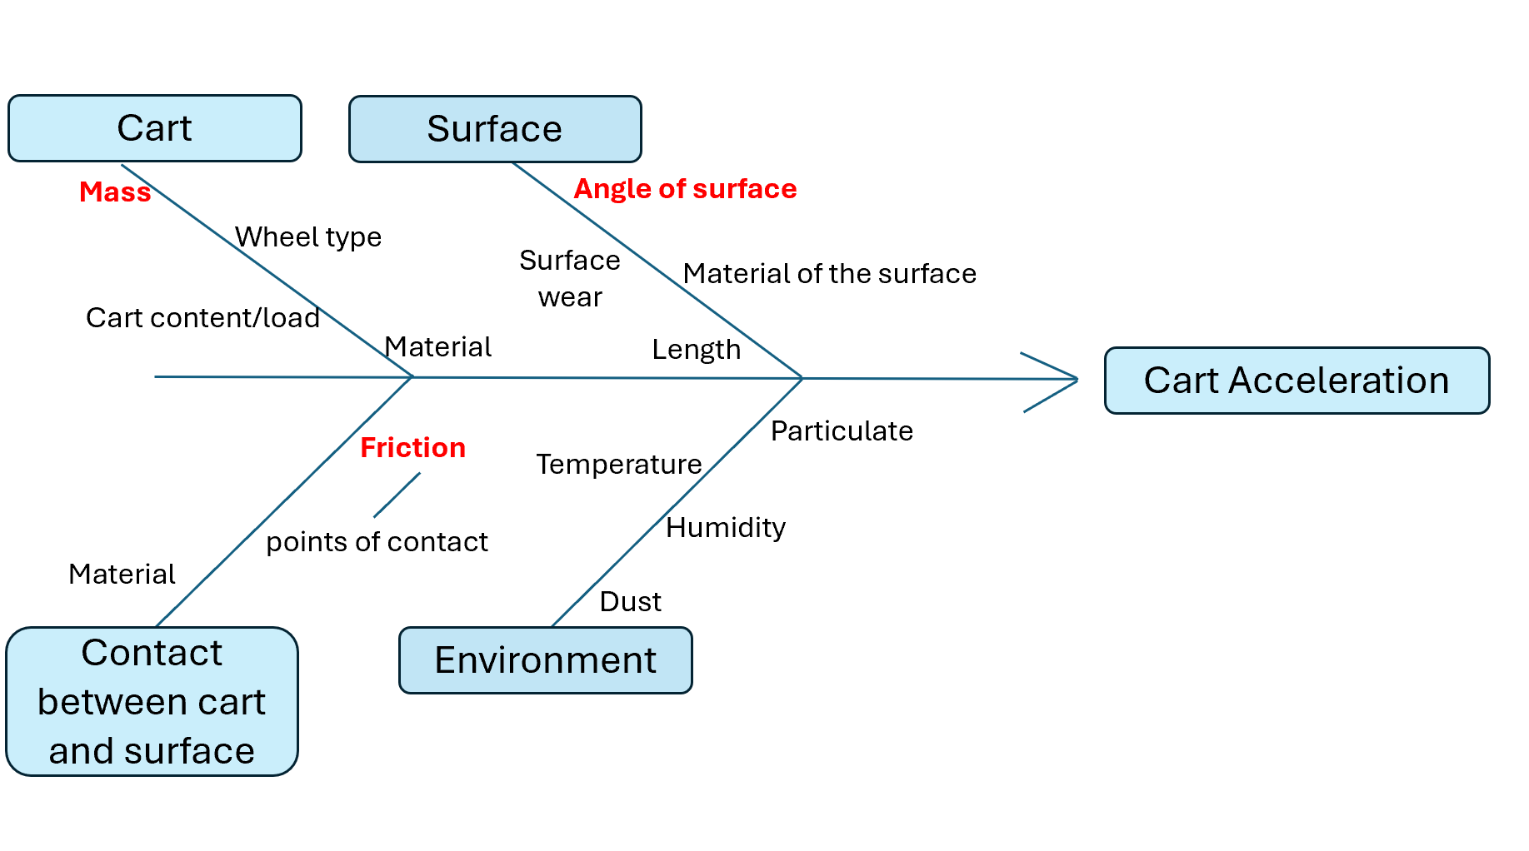
Figure 1. Root-cause Analysis: Ishikawa Diagram

  - Experimental Factors Description
As stated above, the acceleration of an object is proportional to the net force acting on it. In the scenario of the cart on a ramp, there will be a force of friction acting against the movement, and the gravitational force will interact with the cart's mass and create a force that will pull the mass down. (Refer to Figure 2) Applying Newton’s Second Law, we confirm that as the angle increases, the component of gravity that acts parallel to the ramp increases; which makes the acceleration increase. (Newton's laws of Motion 2024) Figure 2, intends to demonstrate the previously stated relation.
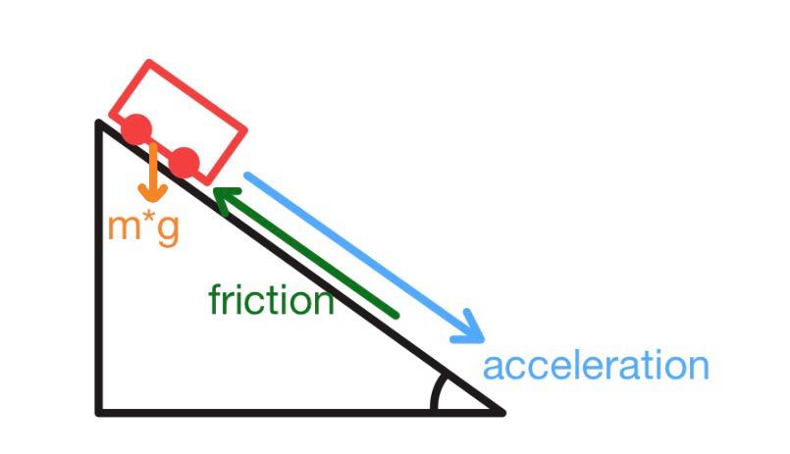
Figure 2. Key Forces Influencing Cart Acceleration

The factors of interest for this experiment are the following:
- Ramp Angle: (Factor A) The ramp angle is the inclination of the surface in which the cart will move. This factor will influence the gravitational force acting on the cart, which directly influences the acceleration. The simulator selected to perform the experiment allows ramp angles from 5° to 60°. To capture the overall effect of the angle of the ramp on the acceleration of the cart, two levels measured in degrees were selected on the lower and upper boundaries of the simulator.
Low level: 5°
High level: 60°
- Cart Mass: (Factor B) Mass is defined by the amount of matter contained; it is a numerical measure of inertia or resistance to change (Mass | definition, units, & facts | Britannica). The greater the mass of a body, the smaller the change produced by a force. Through this experiment, we will measure the influence the car mass will have on its acceleration as it travels down the ramp. The simulator allows the cart mass to vary between 0.1 kg and 2 kg, with increments of 0.01 kg. To capture the full range of the influence that mass may have on the cart’s acceleration, two levels of the limits of the simulator were chosen.
Low Level: 0.1 kg
High Level: 2 kg
- Friction Coefficient: (Factor C) The friction coefficient is defined as the magnitude of frictional resistance between two surfaces, in this scenario, the resistance between the cart’s wheels and the ramp. Since the friction will be a force opposite to the acceleration, it is expected to influence the acceleration negatively. The simulator allows the friction coefficient to vary between 0.000 and 0.200. The levels chosen for this initial experiment were a scenario without friction and a scenario with the highest friction possible (Trento, 2026).
Low Level: μ= 0.000
High Level: μ= 0.200
Factors | Levels
Factors | Low | High | Central Points (4)
Ramp Angle (A) ° | 5 | 60 | 32.5$≈$33
Car mass (B) kg | 0.1 | 2 | 1.05 $≈$1.1
Friction Coefficient (C) μ | 0.000 | 0.200 | 0.1
Table 1. Experimental Information Summary Table

  - Experimental Response Description
The response variable (Y) for this experiment will be the car acceleration ($\frac{m}{s^{2}}$), which is defined as the rate at which the car changes velocity. The simulator used to perform the experiment uses the Successive Difference Method to calculate the acceleration. A detailed explanation of this method is provided in the Execution Phase of the report.

  - Design & Justification
The experiment designed was a $2^{3}$ full factorial design with center points, to evaluate the effects of angle, cart mass, and friction coefficient on the acceleration of the car. This design will allow us to calculate the effect of the factor’s effects and the interaction effects, which is important when the effect of one factor may depend on the level of another factor. The addition of center points will allow us to establish if there is a presence of curvature in the response variable. The $2^{3}$full factorial design results in 8 combinations. The experiment will have 2 replicates (n=2) to estimate the random error accurately, which results in 16 observations. Since four center points were included in the experiment, the number of runs will be 20.

- Execution Phase
  - Discuss Experimental Challenges & Solutions
During the execution phase of the experiment, several practical challenges arose regarding data collection within the simulator environment. The primary obstacle stemmed from the specific mechanism the simulator uses to calculate acceleration. Instead of measuring forces directly, the simulator employs the Successive Difference Method, utilizing distances to calculate acceleration. This process consists of measuring how far the car travels at equal time intervals. Because the mathematical model relies on positional data over these equal intervals divided by a squared time factor, $a=\frac{\left(\left(x_{4}+x_{5 }+ x_{6}\right)-\left(x_{1}+x_{2}+x_{3}\right)\right)}{9t^{2}}$ , relying on manual observation or simulated timing to capture these exact intervals introduces a significant potential for measurement error. Even slight variations in recording the distances can propagate through the equation denominator, causing unintended variance and amplifying the error in the calculated acceleration response. To mitigate this issue and ensure the robustness of the data, standard statistical countermeasures were applied. The experiment was executed with two distinct replicates (n=2) for each of the eight factorial combinations. By replicating the runs, the team was able to estimate random error accurately and minimize the impact of any single timing discrepancy. Furthermore, the complete sequence of runs was randomized. This randomization is a critical solution to prevent any unobserved, systematic execution bias from inflating or deflating the response variable, guaranteeing that the recorded accelerations truly reflect the manipulated factors rather than external simulator noise.

  - Provide Data with its run order
The experiment consisted of 20 total runs, which included the combinations of the 2^3 full factorial design, the established replicates, and the addition of four center points. The data was collected and recorded following a randomized run order to ensure statistical validity. The complete experimental design matrix, including the run order, specific factor levels for Ramp Angle (A), Cart Mass (B), and Friction Coefficient (C), and the resulting Acceleration (Y), is detailed in Table 1 below.
Table 2. Experimental Data and Run Order
- Analysis Phase
As previously stated, a $2^{3}$full factorial design with center points was designed using the statistical tool Minitab and executed with the simulator. The following section contains the results of a descriptive analysis of the data, model construction, interpretation, and model adequacy and validation. All statistical tests were performed with an alpha level of 0.05 unless stated otherwise.
Exploratory Analysis
To obtain an initial understanding of the factors and their behavior an exploratory analysis was conducted.
- Factorial and Cube Plots
The main effects plots, found in Figure 3, illustrate how each factor influences the car's acceleration. Factor A (angle of ramp) has the strongest and most dominant effect, observed in its steep and pronounced slope. Increasing the angle from 5° to 60° results in a significant increase in acceleration. Factor B (mass) shows a very small positive effect. When the mass increases from 0.1kg to 2 kg, the acceleration remains almost the same, indicating that the acceleration doesn't strongly depend on this factor. Factor C (friction) has a negative effect. Increasing the friction from μ=0.000 to μ =0.200 results in a significant decrease in acceleration.
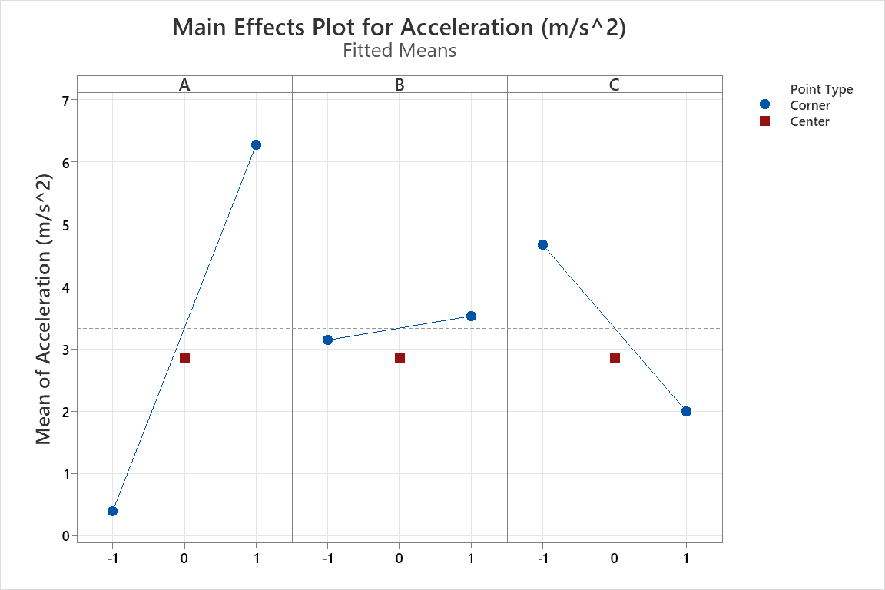
Figure 3. Main Effects Plot for Acceleration
Interaction factorial plots, found in Figure 4, indicate whether the effect of one factor depends on another. In an A x B (angle*mass) interaction, the lines are nearly parallel, indicating little to no interactions at all between factors. In an A x C (angle*friction) interaction, non-parallel lines are observed, indicating a clear interaction between factors. The effect of friction clearly depends on the angle of the ramp. In a B x C (mass*friction) interaction, the lines are almost parallel, with a slight separation between lines, indicating a weak interaction. This suggests that the effects of friction on acceleration does not significantly depend on the mass of the cart.
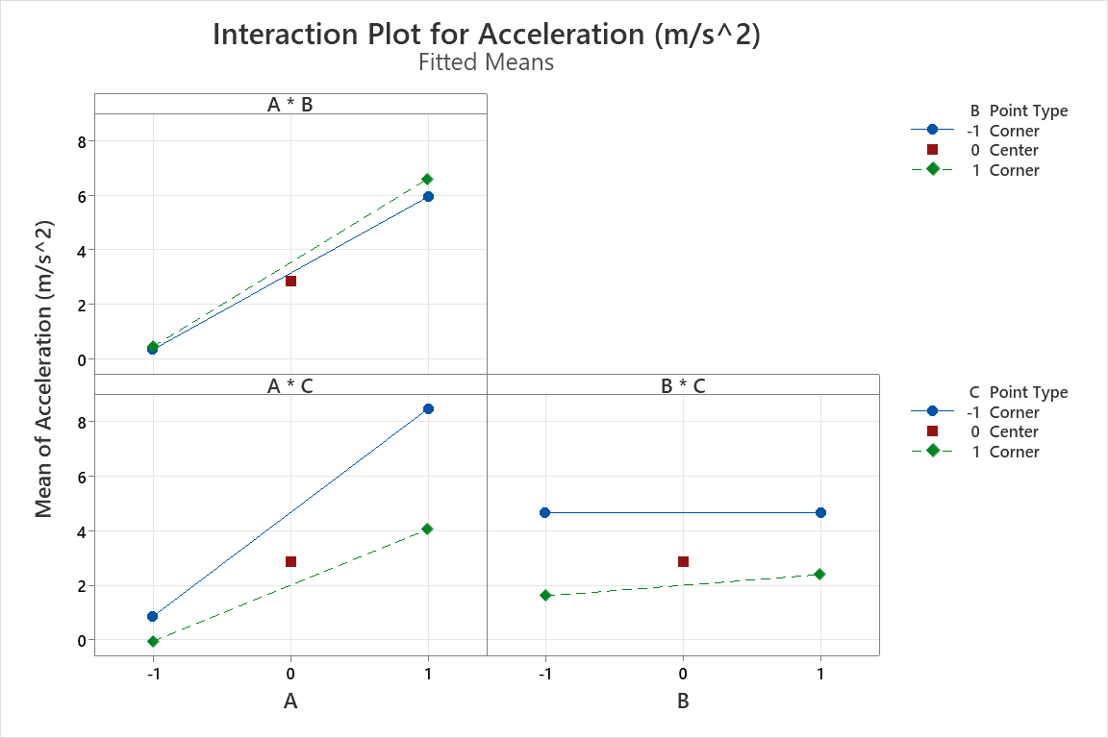
Figure 4. Interaction Plot for Acceleration
The cube plots found in Figure 5, allow us to compare how different combinations of factor levels influence acceleration. The highest acceleration value occurs when A = 1 and C = -1, indicating that every combination with a high ramp angle and low friction results in the greatest acceleration. On the other hand, the lowest acceleration values appear when A=-1 and C =1, showing that low angle and high friction lead to a small acceleration. In both cases, these combinations do not depend on the level of factor B.

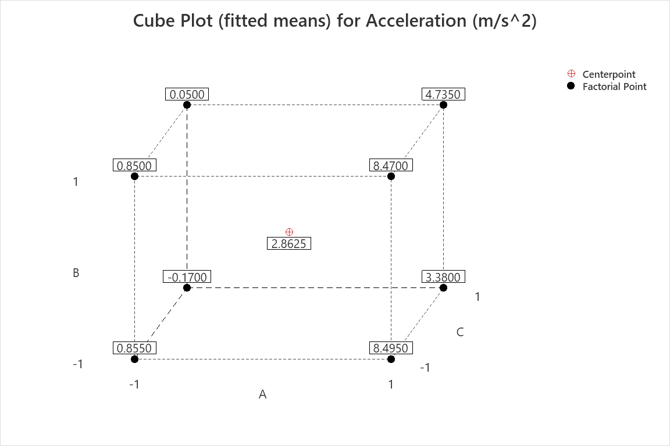
Figure 5. Cube plot for acceleration

- Factor Effect Analysis
We proceeded to perform a mean effect analysis to identify the factors that influence the cart acceleration, and the results confirm the predictions stated before. As seen in Figure 6, all the factors and their interactions were statistically significant since all the p-values were lower than 0.05. This suggests that all factors and their interactions influence the cart's acceleration; however, the magnitude of their contribution varies. Additionally, the center points were also deemed statistically significant, suggesting that there is a curvature presence. In terms of the magnitude of the effects of each factor, all the factors influence the response variable. However, the ramp angle (A), friction coefficient (C), and their interaction have the biggest contribution. While ramp angles have a positive effect on the cart acceleration, meaning that as the angle increases, the acceleration increases, the friction coefficient (C) and the interaction between ramp and angle (A*C) have a negative effect on the acceleration.
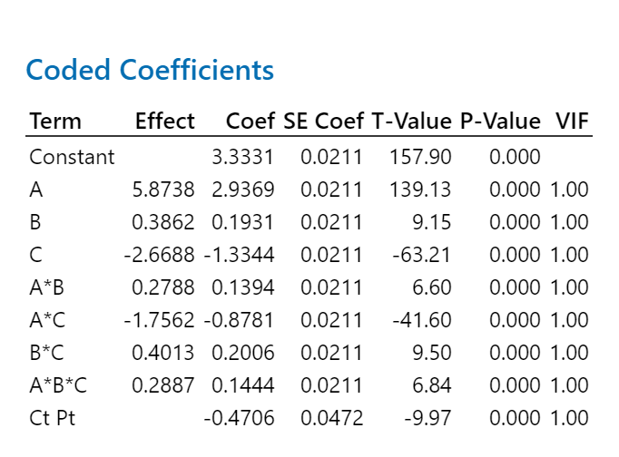
Figure 6. Coded Coefficients

To confirm the suggestions stated previously, a Pareto Chart was developed; refer to Figure 7. The Pareto chart confirms that all factors and interactions are statistically significant since they all go over the reference line (2.2). The ranking of the effects is the same as previously stated. Ramp Angle being the most significant factor, followed by Friction Coefficient and then their interaction. Finally, the Normal Plot (refer to Figure 8) was created which confirmed the behaviors previously stated. Factor A (ramp angle) is the farthest from the reference line, meaning that its effect on the response variable is significant. The location of the effect suggests that it positively influences the response variable. While Factor C (friction coefficient) and the interaction of Factor A and C, seem to stray away from the reference line but on the opposite side. This entails that factor C and A*C are significant but have a negative effect on acceleration. The rest of the factors and interactions cluster around the reference line suggesting a smaller effect on the cart’s acceleration.
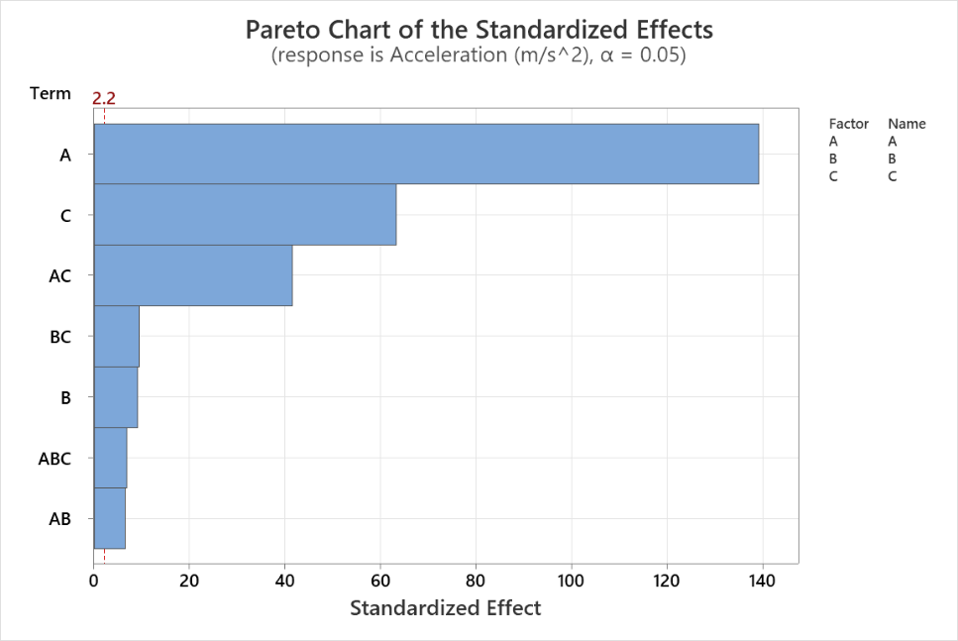
Figure 7. Pareto Chart of Standardized Effects
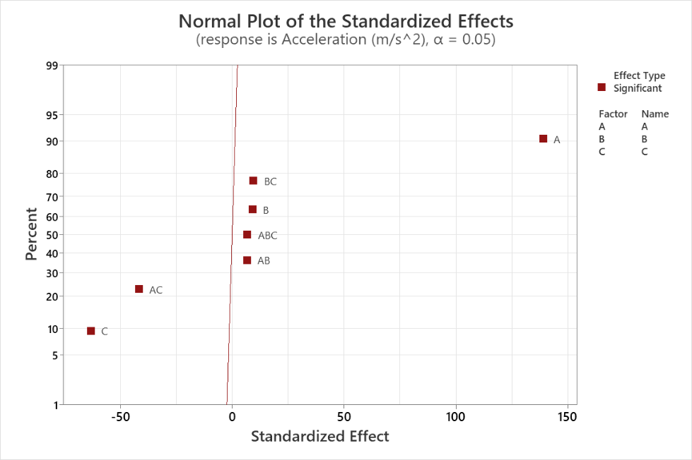

Figure 8. Normal Plot of Standardized Effects

Model Construction and Interpretation
Having gained a preliminary understanding of how the factors and interactions behave, we proceeded to perform statistical analysis.
- Model Summary
The full factorial model presented a very strong fit for the acceleration response. The model obtained an (R^2) of 99.96%, an adjusted (R^2) of 99.93%, and a predicted (R^2) of 99.83%. These values indicate that the model explains almost all the variability observed in the acceleration of the cart. In other words, the combination of ramp angle, cart mass, and friction coefficient is highly effective in describing the behavior of the system.
However, even though the model has a very high (R^2), the adequacy of the model still needs to be evaluated through the residual plots and statistical tests. A high (R^2) means that the model fits the data well, but it does not automatically mean that all assumptions of the model are satisfied.
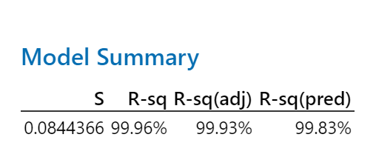
Figure 9. Model Summary R^2

- ANOVA Analysis
The ANOVA results show that the overall model is statistically significant, since the p-value is below 0.05. This confirms that the selected factors and their interactions have a significant effect on the acceleration of the cart.
For the main effects, Factor A, which represents the ramp angle, is the most influential factor in the experiment. It contributes approximately 76.03% of the total variability. This result is consistent with the physical behavior of the system because increasing the ramp angle increases the gravitational component acting along the ramp, which produces a higher acceleration.
Factor C, which represents the friction coefficient, is the second most important main effect, contributing approximately 15.70% of the total variability. This also makes sense because friction directly opposes the motion of the cart. Therefore, when friction increases, the acceleration of the cart decreases.
Factor B, which represents the cart mass, has the smallest contribution among the main effects. This suggests that mass does not have a strong practical effect on the acceleration when compared with the ramp angle and friction coefficient. This agrees with the physical concept that mass tends to cancel out in basic incline motion, although it may still show a small effect when friction is included.
The curvature term was statistically significant and contributed approximately 0.39% of the variability. This is important because it suggests that the relationship between the factors and acceleration is not completely linear. In other words, the acceleration response does not follow only a straight-line behavior as the factors change.
This result justifies moving from the full factorial design to a Central Composite Design, since the CCD allows the experiment to evaluate quadratic terms and better understand the curvature present in the system.

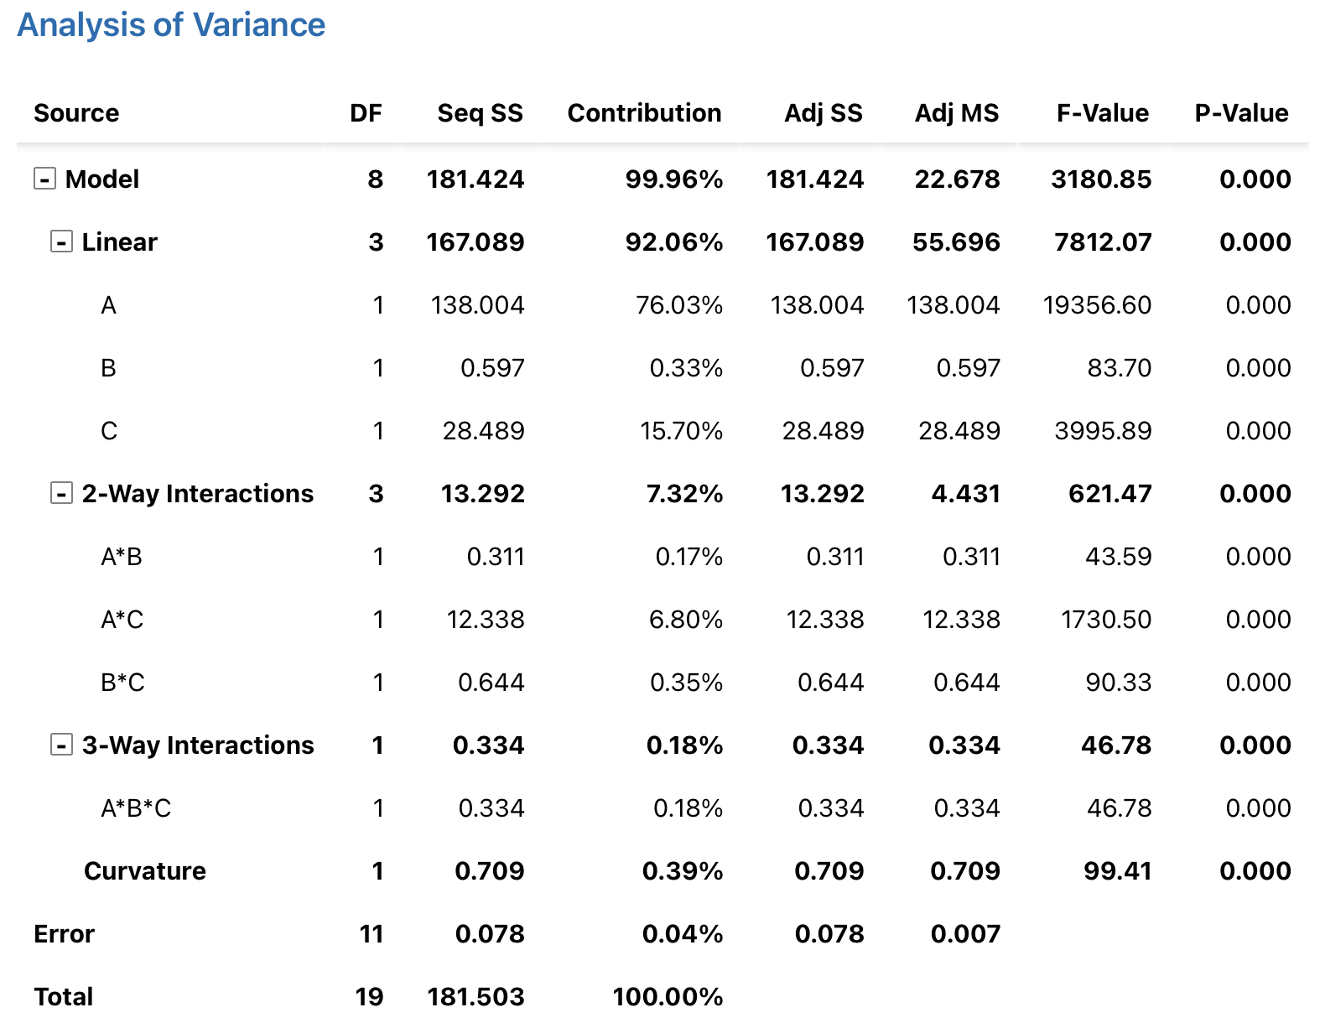
Figure 10. Analysis of Variance
- Regression Equation
The regression equation, illustrated in Figure 11 reinforces the conclusions drawn from the factorial and interaction plots. The ramp angle has the largest positive coefficient of 2.9369, confirming that the increase in the angle results in a strong increase in acceleration. Cart mass has a very small positive coefficient of 0.1931, confirming its weak effect observed in the main effects plot. The friction coefficient has a negative coefficient of -1.3344, indicating that while friction increases, acceleration decreases. The interaction term A x C (angle * friction) is the strongest, with a value of -0.8781, indicating that the effect of friction depends on the ramp angle. The rest of the interactions have smaller coefficients indicating weaker combined effects. Lastly, the center point has a negative coefficient of -0.4706, reflecting a mild downward curvature detected in the system.
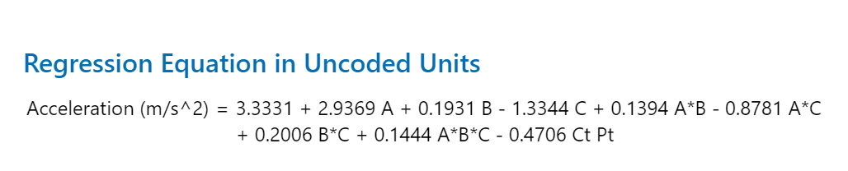
Figure 11. Regression Equation in Uncoded Units
- Variable Selection
All previous statistical analyses have suggested that all factors are statistically significant for the prediction of the cart’s acceleration. However, variable selection analysis was performed to confirm the previous suggestions. The stepwise selection method was developed. As a result, this method suggests maintaining all factors and interactions. The order in which factors were added to the model matches the conclusions of the previous tests. The final model obtained an R-squared value of 99.96%, which indicates an excellent fit to the data. Additionally, Forward and Backward selection methods were developed to confirm the most accurate method for this experiment. These had the same conclusions and results, confirming that the model experiment design was ideal and that no factors should be removed.

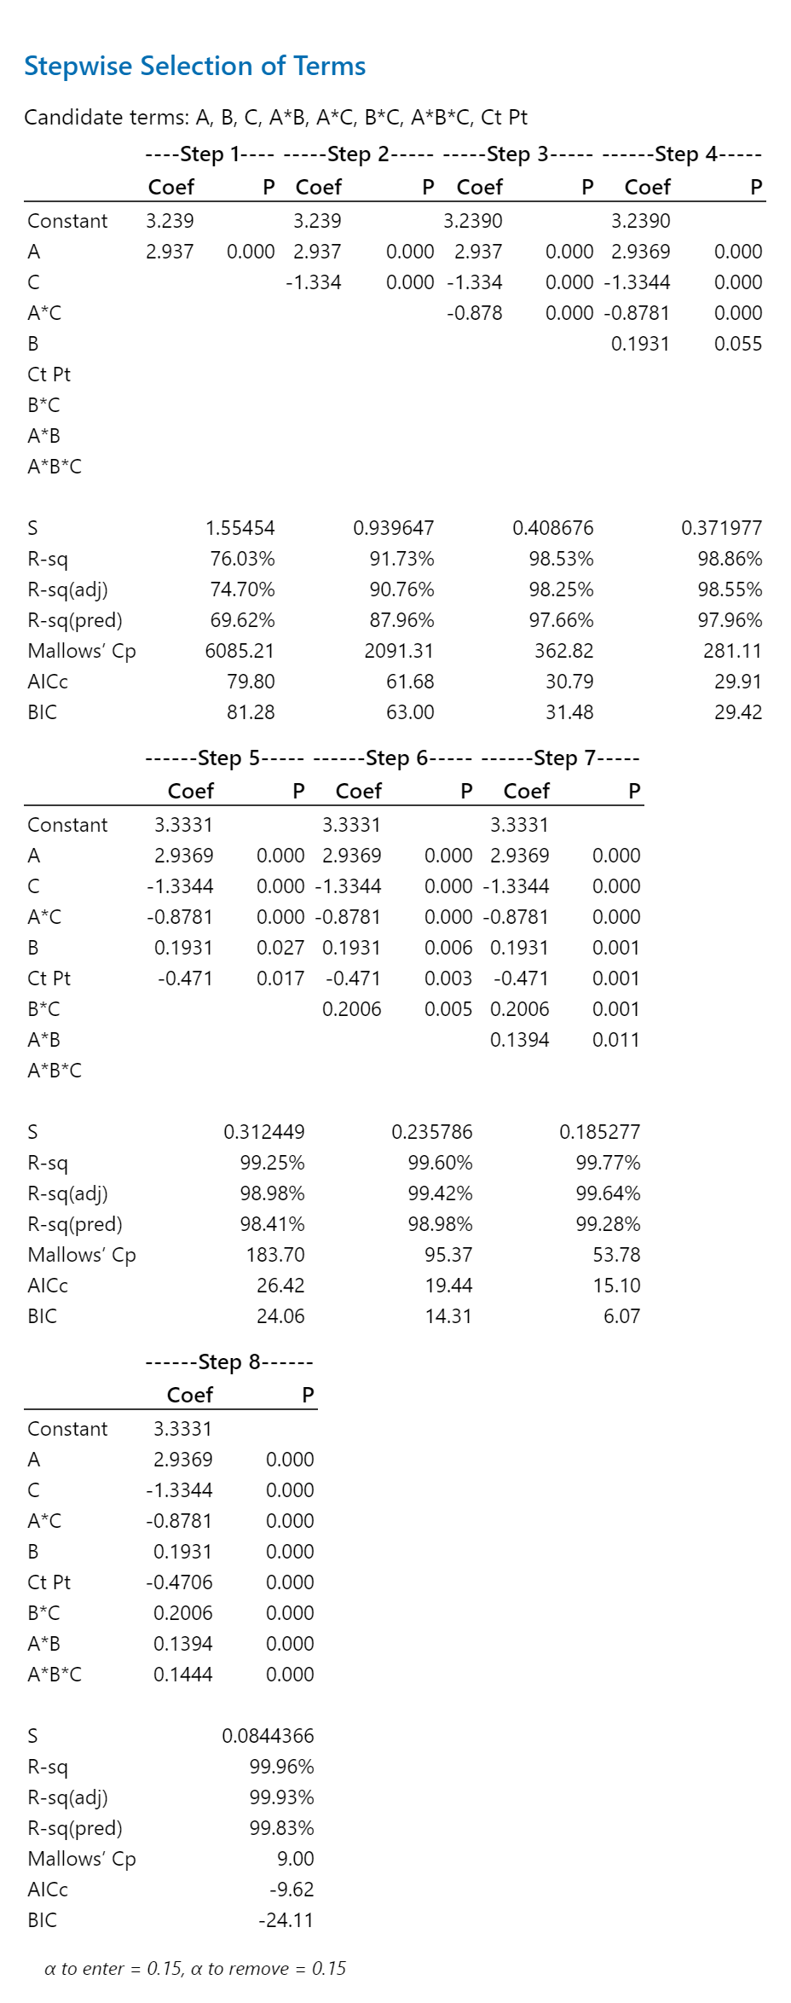

Figure 12. Variable Selection Method

- Residual Analysis
The residuals observed are centered around zero, with most of the values between -0.02 and +0.02. Only two values observed reach -0.195 and 0.195, but they are still considered relatively small, indicating no big issue in the system. The overall pattern suggests that the model fits the data well, with no big outliers or deviations. The residuals obtained with Minitab are found in Figure 13.
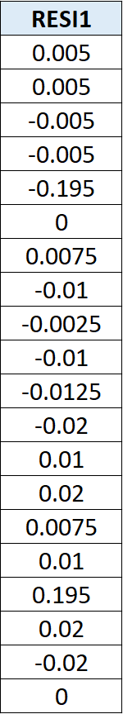
Figure 13. Residuals
- Model Adequacy
Having the model’s assumptions, we must make sure that the assumptions can be trusted through residual analysis.
Subjective Analysis
The normal probability plot of the residuals suggests a departure from normality, especially at the tails of the plot. Some residuals deviate from the reference line, which indicates that the residuals do not perfectly follow a normal distribution. This behavior is likely related to the wide range of acceleration values produced by the experiment. Runs with high ramp angles generate much larger acceleration values, while runs with low angles and high friction generate very small or even negative acceleration values.
The histogram of residuals does not show a smooth bell-shaped distribution. Instead, most residuals are concentrated near zero, with only a few observations farther away from the center. This indicates that the model fits most observations very closely, but some extreme combinations of ramp angle and friction produce larger residuals.
The residuals versus fits plot shows that most points are scattered around zero without a strong funnel shape. This suggests that the constant variance assumption appears reasonably acceptable from a visual perspective. However, this conclusion should be interpreted carefully because the objective tests later show that equal variance is not fully satisfied.
The residuals versus order plot shows some sharp changes in specific observations. This suggests that the independence assumption may be affected. Since some runs with similar factor levels produce similar residual patterns, the residuals may not be completely random across the order of experimentation.
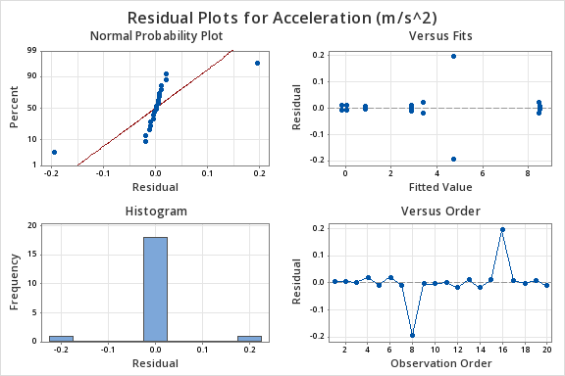
Figure 14. Model Adequacy
Objective Residual Analysis
The Kolmogorov-Smirnov normality test also resulted in a p-value below 0.05. Therefore, the null hypothesis of normality is rejected. This means that the residuals do not follow a normal distribution. This result supports what was observed in the normal probability plot, where the residuals showed deviations from the reference line.
The runs test indicates that the residuals are not completely random. Especially ramp angle and friction coefficient, since these two factors have the strongest effect on acceleration, consecutive runs with similar angle or friction levels may produce similar residual behavior. On the other hand, cart mass does not show the same level of non-randomness, which aligns with its smaller contribution to acceleration.
The Levene's test also rejects the null hypothesis of equal variances. Since Levene’s test is more robust when normality is not satisfied, this result gives stronger evidence that the residual variance is not constant. This confirms that there is a difference in variability between combinations with extreme acceleration values and combinations where the cart barely moves.
Finally, the Durbin-Watson statistic was 0.6917, which suggests positive autocorrelation in the residuals. This result agrees with the residuals versus order plot and suggests that some experimental conditions may have produced patterns that persisted across the run order. It also suggests possible model inadequacy.
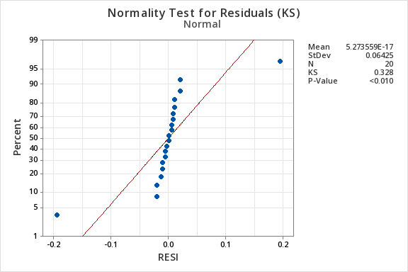
Figure 15. Normality Test

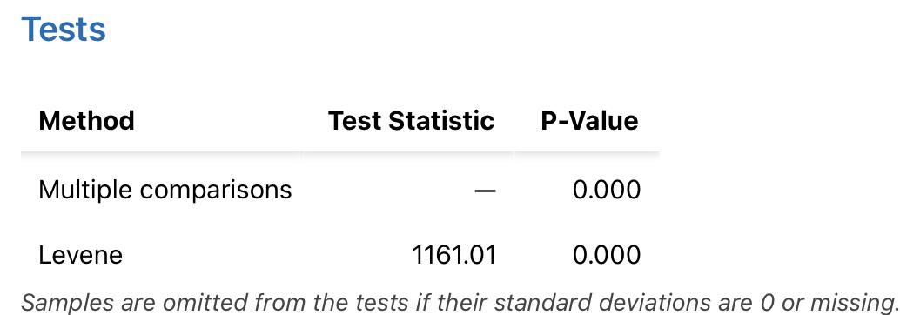
Figure 17. Multiple Comparisons & Levene

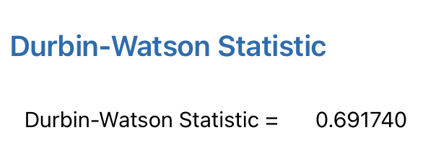
Figure 18. Durbin-Watson Statistic

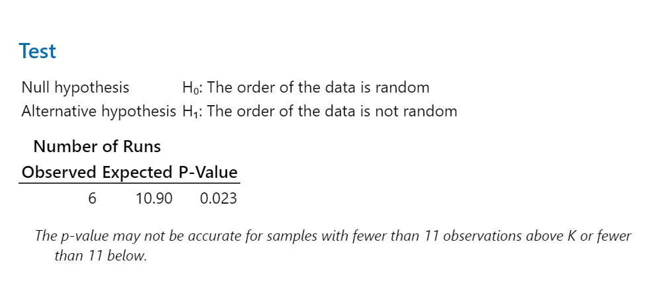Figure 19. Number of runs

Conclusions and Recommendations
Overall, the $2^{3}$full factorial design with center points provided a deeper understanding of the factors and their effects on the cart’s acceleration. The initial predictions were confirmed through the statistical analysis conducted. The ramp angle (factor A), cart mass (factor B), friction coefficient (factor C) and their interaction are statistically significant, meaning that all contribute to the variation of the cart’s acceleration. (Refer to ANOVA results). In terms of magnitude, ramp angle (A), friction coefficient (C) and the interaction between them (A*C) have the highest effect on the response variable. Ramp angles had a positive effect, while friction coefficient and their interaction had a negative effect on the cart’s acceleration. The central points were deemed statistically significant, meaning that there is presence of curvature in the response surface. However, the residual analysis shows that model assumptions were not fully satisfied. This suggests that a first order model design is not adequate to model the relationship between the factors and the cart’s acceleration. The significant curvature supports the decision to continue the analysis using a second order design. Therefore, a Central Composite Design (CCD) is recommended, to further investigate the behavior of the factors, analyze the quadratic terms and quantify the curvature presence in the response surface.
- New Experiment Design & Additional Task
Recommended Experiment: Central Composite Design
Description & Justifications
The experiment previously executed ($2^{3}$full factorial design with center points) indicated that the factors analyzed were statistically significant and the presence of curvature in the response variable. Additionally, some model assumptions were not fully satisfied, suggesting that a first order model was insufficient to describe the relationship between factors and their effect on the response variable. We recommended a second order model to quantify the curvature and further understand the behavior of the cart’s acceleration with quadratic terms. A Central Composite Design will maintain the center points and incorporate axial points to evaluate the response variable over a wider experimental region. It will also allow us to find the optimum combination of ramp angle, cart mass and friction coefficient to maximize or minimize the cart’s acceleration.
Data collected
The three factors were kept at the levels previously stated, referring to Figure 20. Minitab’s default CCD design was adopted, which contains 8 combinations, 6 center points and 6 axial points. We decided to create an experiment with 2 replicates, which resulted in 40 runs, with 16 factor combinations, 12 center points, and 12 axial points.
As stated previously, the CCD design was created using MiniTab and decoded into uncoded combinations to allow the interpretation of the combinations tested in the simulation, referring to Figure 20. The response variable, cart acceleration, was recorded using the simulator with the 40 combinations created.
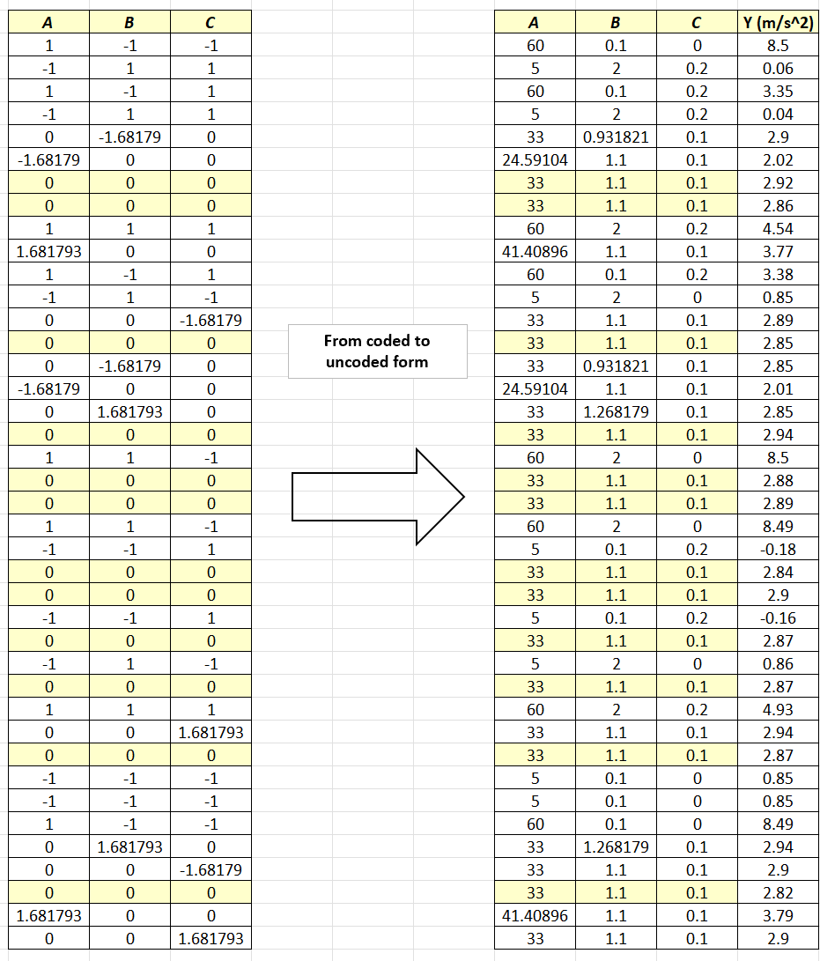
Figure 20. Data collected, coded, and uncoded
Model Construction
Once the simulation was performed, we proceeded to construct the CCD model to initialize the analysis and confirm if the recommended design was ideal.
- Factor Analysis
The same methodology implemented in the first experiment was used. The analysis began by understanding the relationship and behavior of the factors. In Figure 20, we can see the Coded Coefficients results for the CCD. In this case, the factors that resulted statistically significant in terms of the cart’s acceleration were the ramp angle (A), friction coefficient (C) and their interaction (A*C) since their p-values were the only ones lower than the significance level (0.05). These results are interesting since it suggests that the quadratic terms are not statistically significant even though the previous experiment identified curvature. The implementation of the CCD confirms that factors A, C and their interaction (A*C) are important to explain the behavior of the cart’s acceleration. Based on the coefficients for each factor, the factor that mainly influences the cart’s acceleration positively is the ramp angle. While the friction coefficient and the interaction between ramp angle and friction coefficient also influence acceleration negatively. The same behavior was present in the factorial experiment. On the other hand, the Effect Plot and the Pareto chart show the same behavior previously stated, only factors A, C, and A*C seem to be statistically significant. Although curvature presence was detected in the first experiment, further analysis is required to determine if the CCD adequately explains the acceleration behavior.
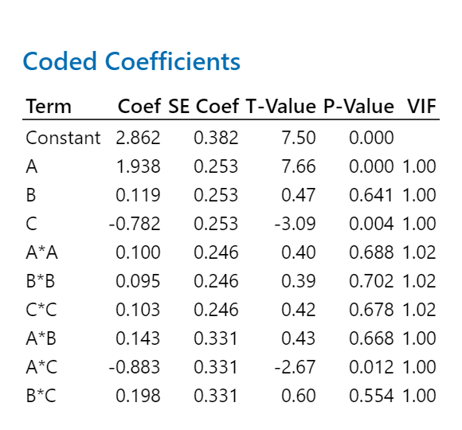
Figure 21. Coded Coefficients
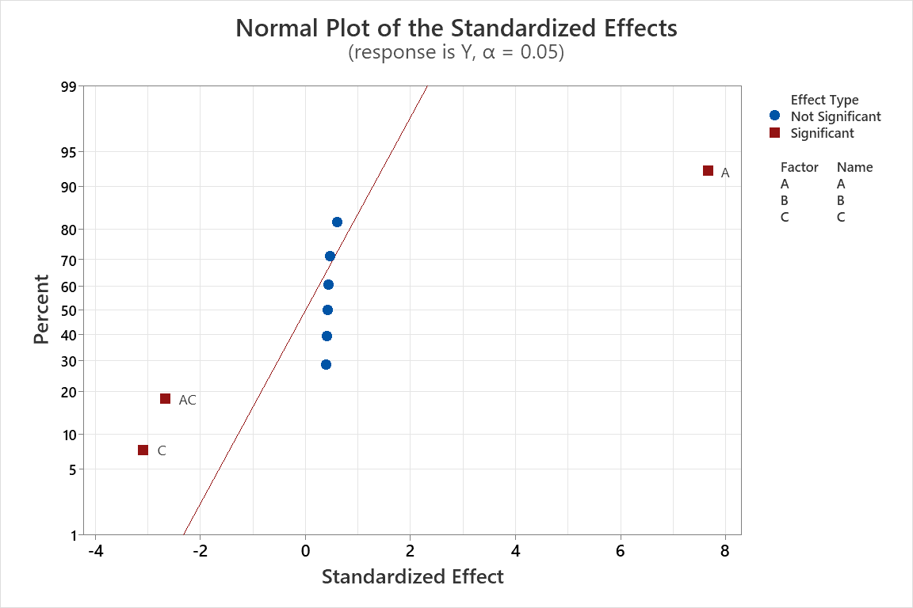Figure 22. Normal Plot
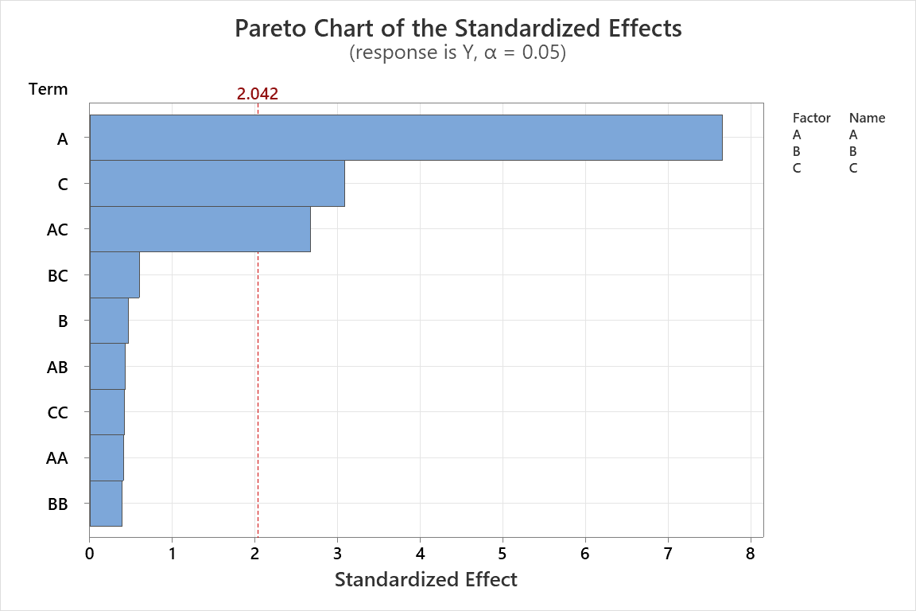
Figure 23. Pareto Chart

- Regression Equation
The regression equation, illustrated in Figure 24, reinforces the conclusions drawn from the coded coefficients results and the half normal plot. The ramp angle has the largest positive coefficient of 1.938, confirming that the increase in the angle results in a strong increase in acceleration. Cart mass has a very small positive coefficient of 0.119, confirming its weak effect observed in the main effects plot. The friction coefficient has a negative coefficient of -0.782, indicating that while friction increases, acceleration decreases. Squared terms capture curvature, indicating that the relationship between each factor is not strictly linear across the experiment. All three quadratic coefficients are positive; if these terms were statistically significant, this would indicate an upward curvature. The interaction term A x C (angle * friction) is the strongest, with a value of -0.883, indicating that the effect of friction depends on the ramp angle. The rest of the interactions have smaller coefficients indicating weaker combined effects.
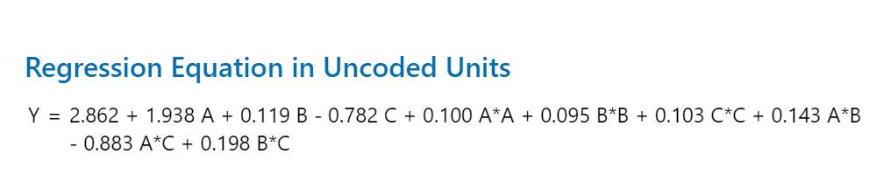

Figure 24. Regression Equation

- Model Summary
The CCD model produced an (R^2) of 71.82%, an adjusted (R^2) of 63.37%, and a predicted (R^2) of 39.56%, refer to Figure 25. These values are lower than the values obtained in the full factorial model. This means that the CCD model explains a moderate amount of variability in acceleration, but it does not predict new observations as strongly as the full factorial model.
The decrease in (R^2) is suggests that the cart’s acceleration is not represented by a quadratic model and lack of fit.
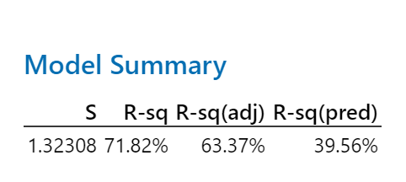
Figure 25. Model Summary

ANOVA Analysis
- Anova
The overall CCD model is statistically significant, since the model p-value is below 0.05. This means that the model contains terms that are useful for explaining changes in acceleration.
For the linear effects, Factor A, ramp angle, remains the most significant factor. It has the highest F-value and a p-value below 0.05, confirming that angle continues to be the dominant factor affecting acceleration. Factor C, friction coefficient, is also statistically significant, which confirms that friction has a strong negative effect on acceleration. Factor B, cart mass, is not statistically significant in the CCD model, which supports the previous interpretation that mass has a small practical effect on the response.
The square terms were not statistically significant. This means that, although curvature was detected in the full factorial design, the individual quadratic terms (A^2), (B^2), and (C^2) do not strongly explain the response by themselves in the CCD model.
For the two-way interactions, the interaction between angle and friction (AC) was the most important interaction and was statistically significant. This confirms the same behavior observed in the full factorial analysis: the effect of angle on acceleration changes depending on the friction coefficient. The other interactions, (AB) and (BC), were not as important in the CCD model. The lack-of-fit test was statistically significant. This means that the second-order CCD model does not fully capture all the behavior present in the acceleration response. Even though the model includes linear, interaction, and quadratic terms, there is still unexplained structure in the data.
This is important because it shows that the physical system may not be completely represented by the fitted response surface model. The acceleration of the cart is strongly affected by angle and friction, but the relationship may be more complex than the model can explain, especially at extreme combinations of the factors.
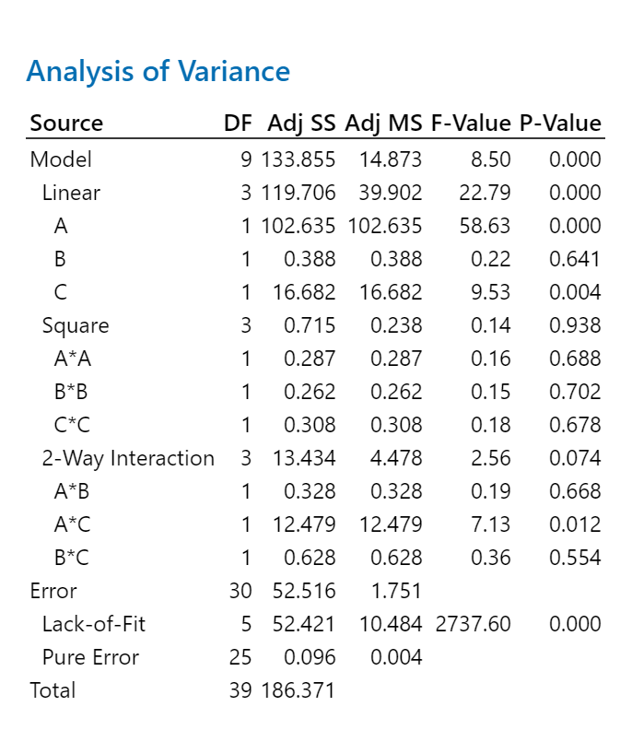
Figure 26. Analysis of Variance

Model Adequacy Checks
- Residual Analysis
To determine if the results of the CCD are statistically valid, the residual analysis was conducted, referring to Figure 27. The residuals were tested for normality, independence, and constant variance, which are assumptions required for ANOVA and other statistical analysis. From the normal probability plot, we can see that most points surround the reference line. There are some slight deviations, which is why the KS test was performed to objectively conclude if the residuals are normally distributed. As shown in Figure 28, the p-value was lower than the significance level(p-value=<0.010) , suggesting that the residuals are not normally distributed. The same behavior was observed on the $2^{3}$ full factorial experiment, suggesting that the models designed fail to explain the behavior of the acceleration in terms of the factors selected. For constant variance, the subjective plot (Residual Vs Fits) shows the residuals scattered without a clear pattern; suggesting that the residuals comply with that assumption. The Residual vs Order plot does not show a clear pattern, suggesting that the residuals are independent. However, objective tests were developed to confirm the behavior. Figure 29 confirms that the residuals comply with the independence assumption.

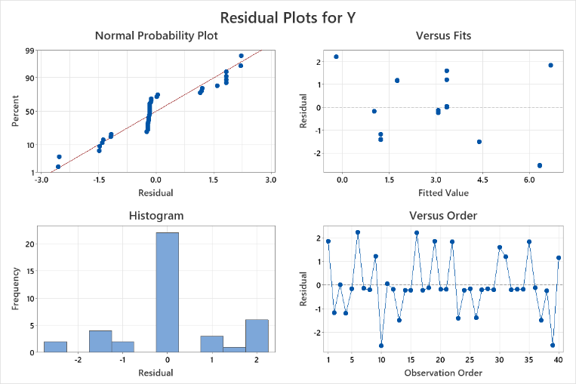
Figure 27. Residual Plots

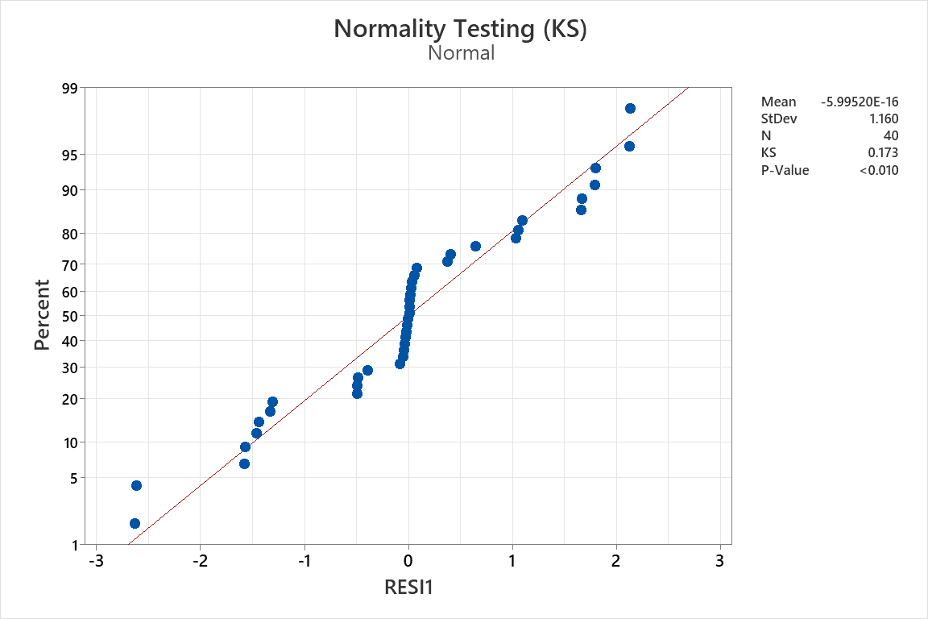Figure 28. Objective Normality Test
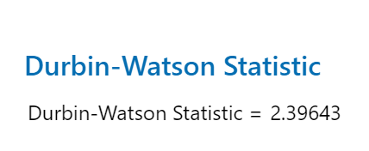
Figure 29. Durbin-Watson - Independence Test

Response Surface
Although the quadratic terms were not statistically significant, the response surface plots were generated to visualize the combined effect of factors. The A*B plot (Cart Mass * Ramp Angle) shows a systematic increase in acceleration as the ramp angle increases; however, the changes in cart mass do not show significant effects. This confirms the suggestions that have been made between these two factors through the factorial design and the response surface design. The C*A plot (Friction Coefficient * Ramp Angle) shows that the highest acceleration occurs when the friction coefficient is low. The contour plot has curved lines, suggesting that the relationship between factors is not linear. These suggestions were also obtained from the full factorial design. While the C*B plot (Friction coefficient * Cart mass) shows smaller changes in acceleration compared to the other plots. This confirms the behavior observed in the statistical analysis where it is indicated that cart mass has little effect on cart acceleration.
The surface plots were generated only to visualize the behavior of the response region since the quadratic terms were not statistically significant and the model showed a lack of fit. Therefore, conclusions on the curvature of the response surface can not be made, since the CCD does not seem to accurately model the behavior of the system.

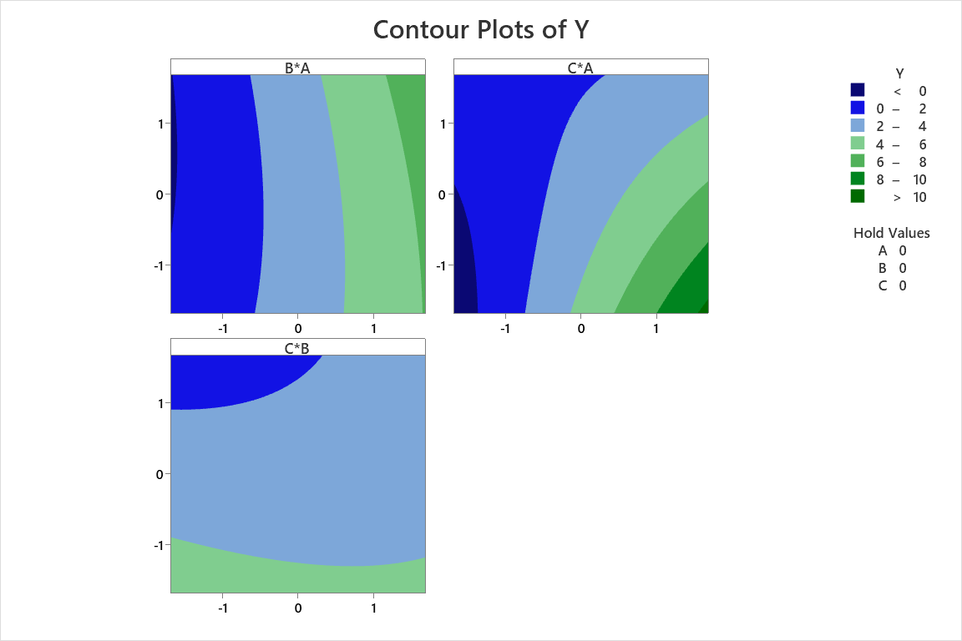
Figure 30. Contour Plot
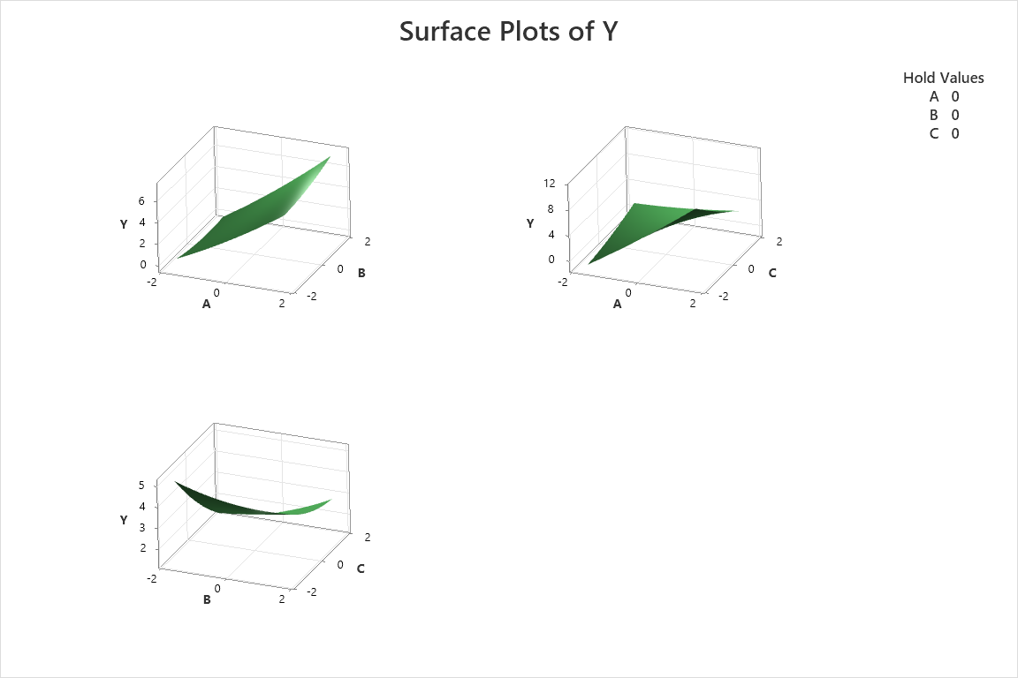
Figure 31. Surface Plots

Optimization
In a similar way, the optimization was performed through Minitab with the intention of finding the optimal settings of angle, mass, and friction coefficient despite the significant lack of fit of the model and the lack of compliance with residual assumptions. As a result, the model predicted a maximum acceleration of $10.8230 \frac{m}{s^{2}}$ with the optimal coded settings as ram angle 1.68, cart mass 1.68 and friction coefficient at -1.68 (refer to Figure 34). These results follow the behavior that the initial factorial design and the central composite design suggested. A higher ramp angle and lower friction coefficient will have a positive effect on the acceleration (maximize). These results also tell us that a higher cart mass is ideal to reach optimized acceleration. We can see that the ideal settings to maximize acceleration are found in the limits of the factors, this behavior may explain the lack of fit of the central composite design and lack of statistical significance in the quadratic terms.
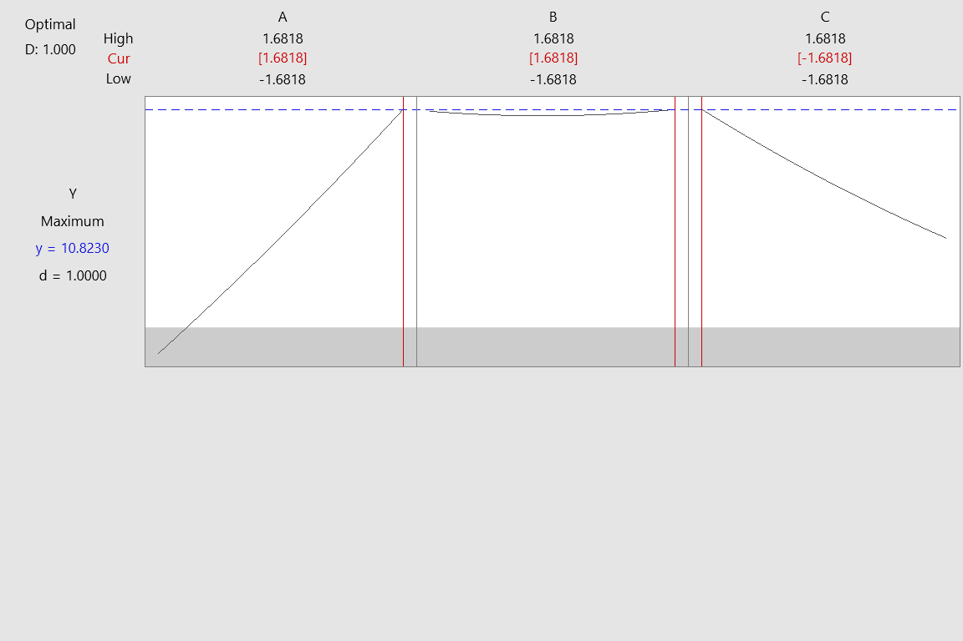
Figure 32. Response Optimizer for Plot

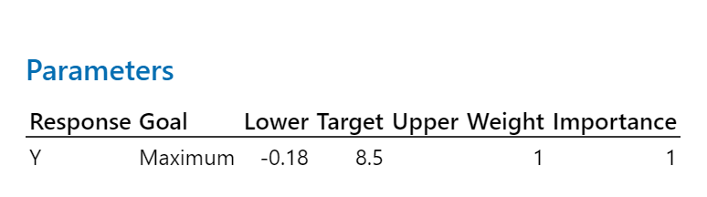
Figure 33. Response Optimizer Parameters
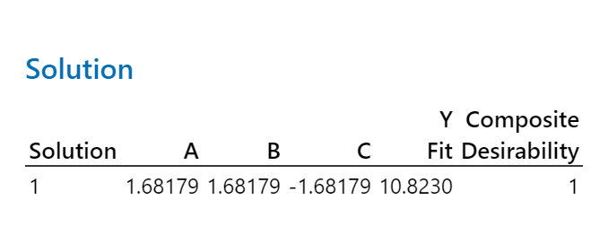
Figure 34. Optimal factor settings

- Final Conclusions
The initial factorial design successfully evaluated how the ramp angle, cart mass, and friction coefficient impact the gravity-driven transport system. The results aligned with Newton’s Second Law: the ramp angle exerted a dominant positive effect on acceleration because a steeper incline equals an increase in the gravitational force acting parallel to the ramp. The friction coefficient did the opposite; it was a direct opposing force to acceleration. Cart mass had no real practical effect on acceleration, which agrees with general Physics laws where mass is largely canceled in motion equations. A significant interaction between the ramp angle and friction was identified, which demonstrates that friction’s effect on acceleration will depend entirely on the ramp angle. Furthermore, the inclusion of center points in this initial design strongly suggests that curvature exists in the response variable.
However, the factorial design did not pass the required statistical model assumptions. Objective residual testing demonstrated that normality and equal variance assumptions were rejected due to the extreme acceleration values generated at the limits of the experiment. The first model was not adequate for complete mathematical analysis. For this reason, the Central Composite Design (CCD) was recommended to properly identify and quantify the curvature within the system’s behavior.
The CCD analysis reaffirmed the dominant physical influence of the ramp angle and the friction coefficient on the system. Continuing with the CCD analysis, the CCD experiment exhibited a statistically significant lack of fit. Ultimately, the lack of fit indicates that the second-order model was not adequate for simulating the acceleration of the cart across the ramp.

- Recommendations
The following actions are suggested to address limitations and refine the experiment’s analysis:
- Reducing variables by focusing all future experiments exclusively on the ramp angle and the friction coefficient, as cart mass was proven to not be statistically significant.
- Utilize Box-Behnken (BBD) designs in future iterations to constrain the experimental space and avoid extreme boundary conditions.
- Transition to modeling with non-linear regression based on actual physical trigonometric equations (following Newton’s Second Law) to resolve the lack of fit.
- Run targeted experiments using the exact optimal settings identified by the CCD.

- References
NASA. (2024, June 27). Newton’s laws of Motion. NASA.
https://www1.grc.nasa.gov/beginners-guide-to-aeronautics/newtons-laws-of-motion/
Urone, P. P., & Hinrichs, R. (n.d.). 5.4 inclined planes - physics. OpenStax.
https://openstax.org/books/physics/pages/5-4-inclined-planes
Mass | definition, units, & facts | britannica. (n.d.).
https://www.britannica.com/science/mass-physics
Trento, C. (2026, March 25). Friction coefficient: Definition and calculation. Stanford
Advanced Materials. https://www.samaterials.com/content/friction-coefficient-
definition-and-calculation.html
SciSimulator. (n.d.). CART acceleration simulation: Speed-time analysis: Free Virtual
Physics Experiment. https://scisimulator.com/en/experiment/phys-cart-acceleration

- Appendix
- Minitab Execution File (Attached on Moodle)
- Final Presentation_Group#2 (PDF attached to this document)
- Final Presentation Video Link: Final Presentation_ININ4027_Group#2 - Cart Acceleration.MOV

